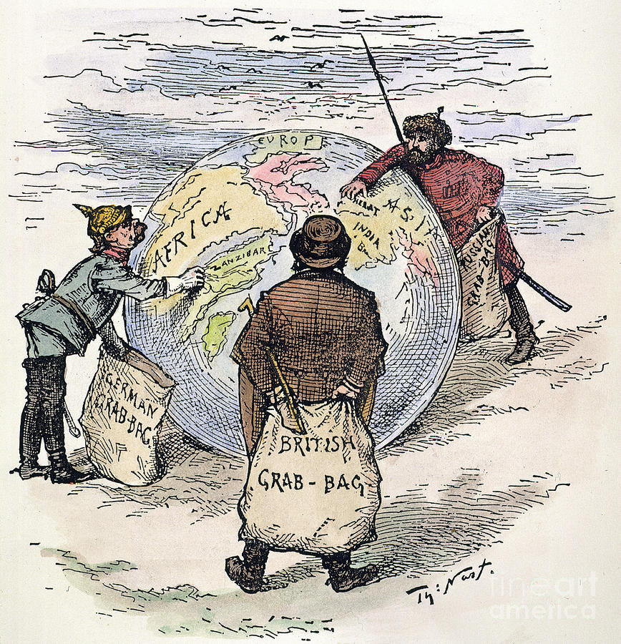
Unit 1: Political Imperialism
Review Guide – Test Day __________________________

- Explain each of the 5 motives of imperialism (EMPIRE):

- What inventions/technology helped Europe colonize (especially in Africa)?

- Which colony was considered Britain’s “jewel in the crown?” Why?

- What is the difference between indirect and direct imperialism?

- What was the British Raj?

- What was the Sepoy Rebellion (where, why, and what was the result)?

- How did Great Britain use India to create trade with China?

- What was the age of New Imperialism? How did it differ from old imperialism?

- What is a sphere of influence?

- What was the poem “The White Man’s Burden” about? Who was it written by?

- What is Social Darwinism?

- List the reasons the Europeans desired to colonize Africa during the age of New Imperialism:

- What was the Berlin Conference and what happened as a result?

- Which 2 African countries were able to maintain independent during European colonization (until after 1914)?

- What 2 discoveries in South Africa caused prospectors to move there in large numbers during the late 19th century?

- Who were the Boers? What was the Boer War?

- What caused the Zulu’s to rebel?

- What highly desirable resource was discovered in the Congo? How were the natives in the Congo treated under King Leopold? Which European power assumes control of this region?

