Wrapping up Political Imperialism
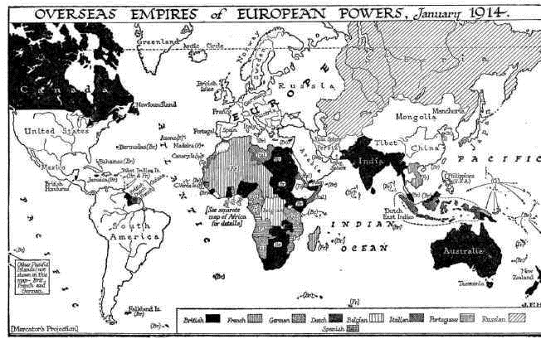
Part I – Global Imperialism (1900)

- List the 4 continents Great Britain had extended colony influence to by 1900:
__________________________
__________________________
__________________________
__________________________

- How many continents had France extended colony influence to by 1900:

Part II – The Boer War 1899 (2nd Boer War). Use the terms below to complete the excerpt.
Great Trek slavery
Australia gold
Dutch Canada
Diamonds Zululand

The Boer people (also called Afrikaners) were descended from the early ___________________ settlers at the Cape of Good Hope from 1652. When ___________________ was abolished in 1834 the alienated Boer farmers decided to resettle in the north. So started the “________________________”. Constant armed and diplomatic confrontation with British Administration eventually led to the independence of Transvaal and Orange Free State (Boer territories) in 1852 and 1854. The discovery of _____________________ in huge quantities led to the annexation of Boer territory. In 1879 British Forces invaded _________________________ resulting in disastrous military campaigns. By 1880 the Boers rose in revolt against their new British controlled government. In a series of skirmishes they inflicted three small but shattering defeats to the British. The discovery of ______________________ in 1886 attracted an influx of British and other foreign prospectors. In 1896 a further attempt was made to take Transvaal. This was resisted again. Military aid for the Boers started pouring in from Germany and France including rifles, maxim machine guns and field guns. Transvaal demanded a withdrawal of all British troops from its borders and the recall of troops currently in transit to South Africa. Britain did not respond and subsequently state of war existed from 1899-1902. The Boers were eventually defeated by British troops who drew on support from their other colonies in _________________________ and ________________________.

Part III – One More Motive for Imperialism

- What is nationalism? ______________________________________________________________

Carefully examine the political cartoon. Then answer the question that follows.
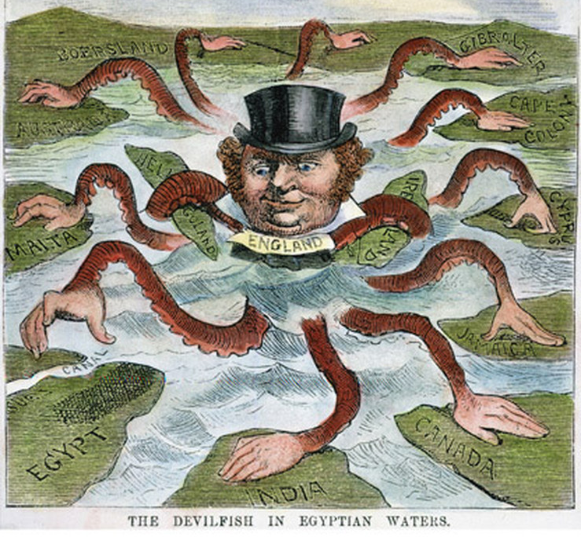

- What is the relationship between nationalism and imperialism? EXPLAIN how the first leads to the second using the cartoon as your example.

Part IV – Belgium’s Heart of Darkness – Read the following article and then answer the questions below.

http://www.historytoday.com/tim-stanley/belgiums-heart-darkness

- Which African country did King Leopold receive from European powers in 1885?

- What natural resource was soon discovered in the jungles that King Leopold began to harvest?

- The native inhabitants were horribly brutalized under King Leopold’s orders. Explain what happened if a village failed to meet their quota:

- Based on the context of the reading – who were the “gendarmerie?”

- In order to ensure that the gendarmerie did not use their bullets for hunting for food – what did the Belgians require them to bring back?

- Who was Joseph Conrad? What is he known for?

- How did the atrocities in the Belgian Congo finally come to an end?

