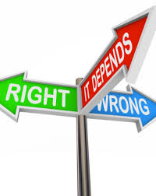
Happy, Fun Moral Development Notes!
-the development of principles that guide how we treat others

Part I – Lawrence Kohlberg
- Discontinuous theory
- People develop morality through stages
- Not every person will reach the highest stages
- Consists of three levels and six stages overall

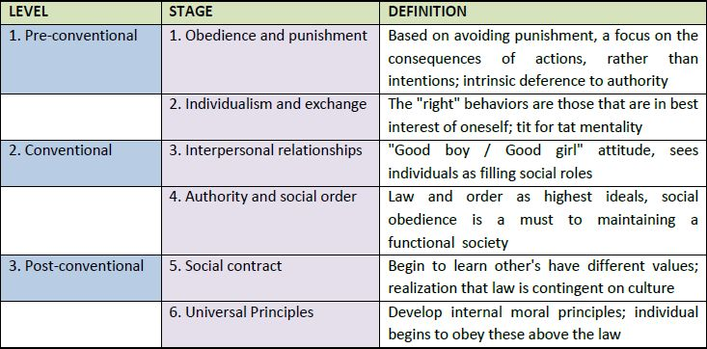

Kohlberg’s Levels of Moral Development

Pre-conventional
Stage 1: Moral decisions are based on consequences of the action. “Will I be punished?”

Example __________________________________________________________________________________

Stage 2: Moral decisions are decided on the benefits derived from the action. “Will I get what I want?” In this stage, decisions are also made on the principle of reciprocity. “Does the victim deserve it?”

Example __________________________________________________________________________________

Conventional
Stage 3: Moral decisions are determined by evaluating the action in terms of love and approval of family and friends. “Will my family or friends get mad at me?”

Example __________________________________________________________________________________

Stage 4: Moral decisions are based on the precepts of law/and or religion. “Is this right according to the law/and or religion?”

Example __________________________________________________________________________________

Post-conventional
Stage 5: Moral decisions begin to account for the differing values, opinions and beliefs of other people. Rules of law are important for maintaining a society, but members of the society should agree upon these standards. “Rules should sometimes be broken.”

Example __________________________________________________________________________________

Stage 6: Kohlberg’s final level of moral reasoning is based upon universal ethical principles and abstract reasoning. The individual establishes his/her own rules according to a personal set of ethical principles.

Example __________________________________________________________________________________
So why don’t we love Kohlberg?
- After conducting multiple tests, it was discovered that one specific group always scored highest on Kohlberg’s moral scale…MEN
- According to Kohlberg’s theory, men were universally more morally developed than women
- Strangely, some psychologists took issue with this…

Part II Carol Gilligan’s Stages (A female perspective) Her research reflected that women’s development was set within the context of caring and relationships, rather than in compliance with an abstract set of rights or rules.

Level I: Preconventional Level Orientation to Personal Survival
  - Stage 1: Caring for oneself
  - Stage 2: Caring for oneself judged to be selfish
  - Transition 1: from personal selfishness to responsibility

Level II: Conventional Level Goodness as Self-Sacrifice
  - Stage 3: Goodness is caring for others, frequently equated with self-sacrifice
  - Stage 4: illogic of the inequality between self and others becomes evident; search for equilibrium
  - Transition 2: from goodness to reality

Level III: Post-conventional Level The Morality of Non-Violent Responsibility
  - Stage 5: focus on dynamics of relationship to eliminate the tension between self and others
  - Stage 6: care is extended beyond personal relationships to a general recognition of the interdependence of self and other, accompanied by a universal condemnation of exploitation and hurt

Part III Piaget’s Cognitive Theory of Morality

Morality of Constraint: moral rules are handed down by authority figures. They are unchangeable and unbreakable. Following rules is based upon fear of consequence.

Morality of Cooperation: moral rules are socially agreed upon guidelines designed to fit the group. Decisions are made based upon more than just fear.
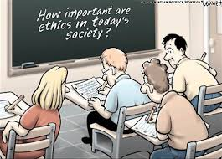

Part IV Empathy as a Moral Motivator

- Development of empathy contributes to prosocial behavior ___________________________________________________________________________

- Progresses from infancy through adulthood

  - Global empathy – distress cues from others may cause an infant to react as though it happened to them (0-1 year)

- Children will match emotions they witness

  - Empathic distress – feeling the perceived pain of another person
(1 year-adolescence)

- Children will feel the emotional pain of another person and respond accordingly
- Early on the child will attempt to help the other in distress, but from their own point of view. For example, a child may bring another crying child to her mother instead of the child’s own mother.

  - Empathy (adolescence onwards) understanding another person's condition from their perspective. You place yourself in their shoes and feel what they are feeling.

