Chapters 9 and 11 Calendar 2017
Motivation and Emotion (6-8%) and Social Psychology (8-10%)
Class Date | In-Class Content | Homework Assignment  (DUE next class)
- Tuesday, January 24th  - Wednesday, January 25th | Achievement Motivation  Motives in Conflict  Sexual Response | Chapter 9 Reading Notes pp. 375-386 Theories of Emotions
- Thursday, January 26th  - Friday, January 27th | Theories of Emotion  Chapter 9 Study Guide Given | Chapter 10 Reading Notes pp. 404-414 Physiological Factors: Stress and Health
- Monday, January 30th  - Tuesday, January 31st (Advisory schedule)  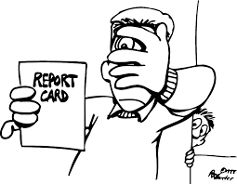 | Stress  Video Application Activity – Theories of Emotion Practice | Study for Chapter 9 Test (w/Stress)  - 50 MC  - 1 FRQ
- Wednesday, Feb 1st  - Thursday, Feb 2nd | Chapter 9 Test Motivation and Emotion (now with Stress!)  50 MC  1 FRQ | Chapter 11 Social Psychology Reading Notes pp. 426-437 Conformity, Group Behavior, and Obedience
- Friday, Feb. 3rd  - Monday, Feb. 6th | Intro to Social Psych - Conformity and Obedience to Authority | Chapter 11 Reading Notes pp. 461-469 Aggression, The Bystander Effect, and Prosocial Behavior
- Tuesday, Feb. 7th  - Wednesday, Feb. 8th (2hr early dismissal day) | Group Dynamics The Bystander Effect Video Analysis - Jonestown  Chapter 11 Study Guide Given | Chapter 11 Reading Notes pp. 450-460 Prejudice and Discrimination AND Interpersonal Attraction
- Thursday, Feb. 9th  - Friday, Feb. 10th | Finish video analysis – Jonestown  Stanford Prison Experiment  Prejudice and Discrimination – A Class Divided | Chapter 11 Reading Notes pp. 439-449 Attitudes, Impression Formation, and Attribution theory
- Monday, Feb. 13th  - Tuesday, Feb. 14th | Attitudes and Cognitive Attributions Persuasion | Dear Abby Letter (FRQ Practice! Apply interpersonal attraction theory to give advice!!!)  Begin Studying for Chapter 11 Test
- Wednesday, Feb. 15th  - Thursday, Feb. 16th | Wrap up Social Psych  FRQ Practice  Will the Winners Lose…if we have time | Study for Chapter 11 Test
- Friday, Feb. 17th  Monday, Feb. 20th – No School  - Tuesday, Feb. 21st  3rd MP Interims sent home on Fri. 2/24! | Chapter 11 Social Psychology Test  50 MC  1 FRQ | Chapter 8 Development Across the Lifespan Reading Notes pp. 310 – 323 (stop at Cognition) Physical Development Prenatal, Infancy, Childhood
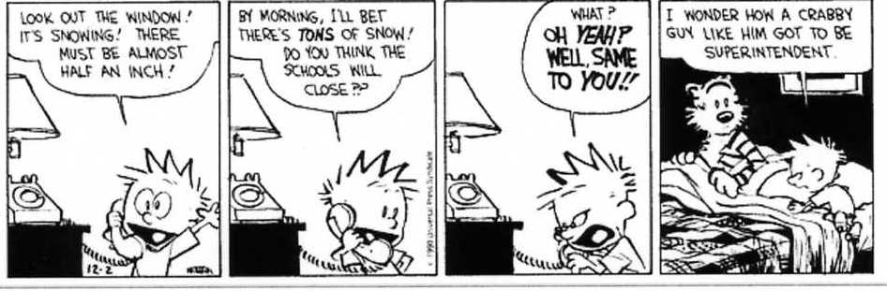
F.Y.I
- In the event of SNOW, and the inevitable school closure – you are to continue your reading assignments! STAY ON TRACK FOR READING NOTES. I will send out a message on REMIND to give instructions for the missed class notes/assignments. NO EXCUSES

This calendar is impressive and NOTHING is going to get in the way…I mean it. We’re on a schedule here people

