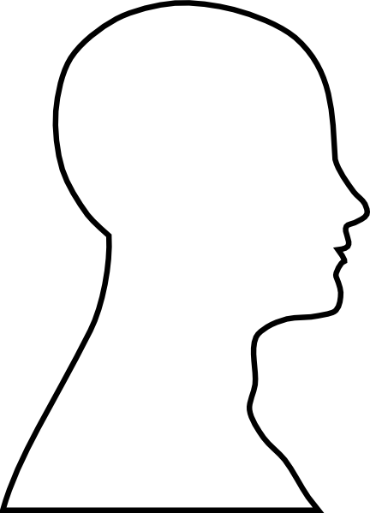

My Personality Profile

My Personality Profile Project

Objective: Create a collage that identifies 10-15 elements of your personality that you would like to share about yourself!

Materials: Choose from the following materials –
- Markers
- Colored pencils
- Magazine clippings
- Clip art and/or photos
- Embellishments (anything to create eye-appeal)

Project Requirements:
- 10-15 elements of your personality - The elements of your personality can be conveyed through personal drawings, words, clip art, pictures, and/or magazine clippings. (Questions to consider: Who are you? What are your likes? Dislikes? Sports and/or hobbies? Favorite foods? Favorite music? Favorite movies? Family life – siblings? Travel experiences? Goals – college/career? And so on…)

- Color – must incorporate 3- 4 colors. This means color enhances the project’s eye-appeal. For example, color photos, color clip art, or personal drawings that include color. It does NOT mean that you hastily scribble color into the project.

- Neatness and legibility – You may hand-write information (labels/names etc.) or type, but all writing must be neat and legible. In addition, carefully consider placement of pictures/clip art etc.

Rubric

Outstanding  A | Good  B | Satisfactory  C | Unsatisfactory  D
All minimum project requirements were met and/or exceeded.  Well organized and personality elements are clearly represented.  Visually creative with thorough attention to detail. | 1-2 project requirements were not met  Organized and personality elements are clearly represented.  Visually creative | 3 of the minimum project requirements were not met.  Organization needs work and/or personality elements were not clear.  Lacking visual creativity. | 4 or more of the minimum project requirements were not met.  Messy and/or hard to understand  Lacking visual creativity and/or effort.

