The Stanford Prison Experiment
In 1971, Philip Zimbardo conducted a notorious study on human behavior by setting up a fake prison. Learn more about the Stanford Prison Experiment and the ethical questions it raised, and test your knowledge with a quiz.

The Study
Zimbardo and his colleagues in the Stanford University psychology department were interested in studying social roles and the way they influence people's behaviors. They advertised for volunteers who wanted to earn $15 dollars a day for two weeks. The 24 men who were chosen for the experiment - mostly middle-class college students - were randomly divided into two groups: prisoners and guards. They were placed in the basement of a building at Stanford.
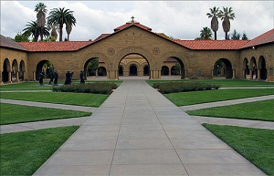
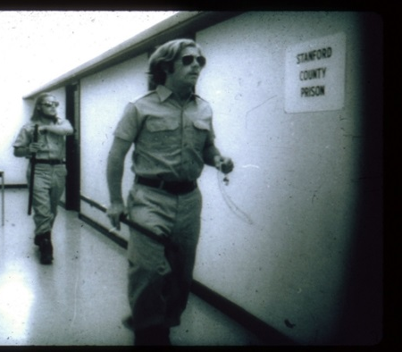
Jordan Hall, Site of the Experiment
The guards were told that they had to keep control of the prisoners, but were not allowed to use physical force. The prisoners were given a list of seventeen rules that the guards wrote up. They included the requirement that prisoners address each other by their prisoner number, not name, and they were not allowed to refer to their situation as an experiment. The researchers monitored the situation via video cameras.
On the second day, the prisoners staged a revolt. After getting the prisoners under control, the guards realized that they needed to assert their authority. Because they were not allowed to use violence, the guards got creative about how to control the prisoners. They woke the prisoners up several times during the night, causing sleep deprivation. They forced some of them to clean toilets with their bare hands. One of the guards said that he asked himself, 'How can we top what we did yesterday? How do we do something even more outrageous?' As a result, the degradation of the prisoners continued to grow more and more out of hand.
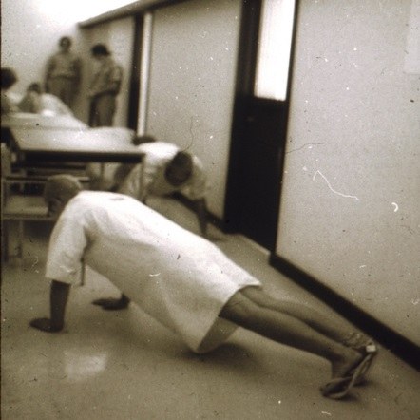
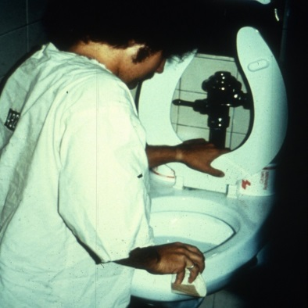
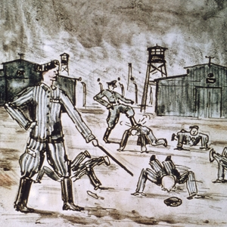

Humiliation of prisoners by forcing them to clean the toilets with bare hands
The prisoners were forced to do push-ups for punishment. Sometimes the guard would place their foot on the prisoners back during push-ups
Push-ups were often used as punishment by Nazi guards in concentration camps

The Intervention
Early on, the prisoners began to display anxiety and depression as a result of the humiliation from the guards. The experimenters released several prisoners early due to severe psychological reactions. But none of the researchers questioned whether the study should end early, despite the escalating actions of the guards.
On the fifth day of the experiment, Zimbardo's then-girlfriend, Christina Maslach, visited the faux prison. She was horrified at the conditions and told Zimbardo so. After she confronted him about it, Zimbardo realized that he needed to stop the experiment. The next day, the prisoners and guards were released. Though many of the participants were distraught at the time, subsequent follow-ups showed that none seemed to have suffered long-term problems from the study.

Termination
The study was terminated on August 20, 1971. The next day, there was an alleged escape attempt at San Quentin. Prisoners in the Maximum Adjustment Center were released from their cells by Soledad brother George Jackson, who had smuggled a gun into the prison. Several guards and some informant prisoners were tortured and murdered during the attempt, but the escape was prevented after the leader was allegedly gunned down while trying to scale the 30-foot high prison walls.

Less than one month later, prisons made more news when a riot erupted at Attica Prison in New York. After weeks of negotiations with prisoners who held guards hostage while demanding basic human rights, New York Governor Nelson Rockefeller ordered the National Guard to take back the prison by full force. A great many guards and prisoners were killed and injured by that ill-advised decision.

One of the major demands of the prisoners at Attica was that they be treated like human beings. After observing our simulated prison for only six days, we could understand how prisons dehumanize people, turning them into objects and instilling in them feelings of hopelessness. And as for guards, we realized how ordinary people could be readily transformed from the good Dr. Jekyll to the evil Mr. Hyde.

The Ethical Questions
Despite the lack of lasting psychological effects on the subjects, many psychologists have criticized the study for causing mental anguish. Because the experiment was conducted on humans, the ethical questions raised by the outcome are very real. Besides the questions surrounding the situation at the fake prison, some scientists have also raised the question of why Zimbardo allowed the experiment to continue for so long.
Zimbardo himself has acknowledged that there are some issues of ethics involved with regards to the study and has apologized for his role in causing damage. He believes that future studies like his should have someone oversee them who is not involved in the experiment, so that they can stop it if things get out of control.

Discussion Questions:
- When setting up the experiment, they made certain to have minimal sensory stimulation. There were no clocks and no windows (to view outside world). What effect do you think this would have on the participants?

- All the prison guards were given dark sunglasses to wear. What effect do you think this had on both the “guards” and the “prisoners?”

- Most prisoners believed that the subjects selected to be guards were chosen because they were bigger than those who were made prisoners, but actually, there was no difference in the average height of the two groups. What do you think caused this misperception?

- What is the most important “take-away” from this study in social psychology? (What is the most important thing to be learned based on this study???)

