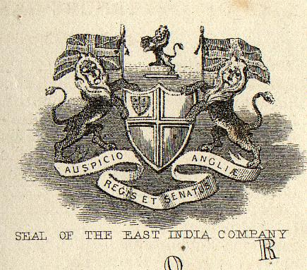 | 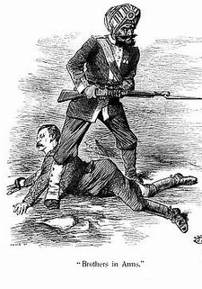  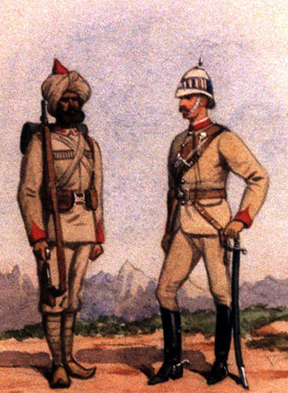 | 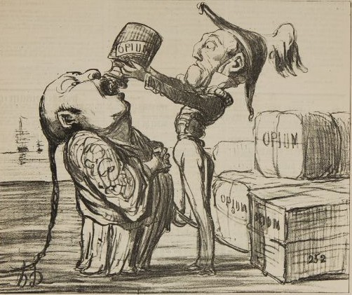
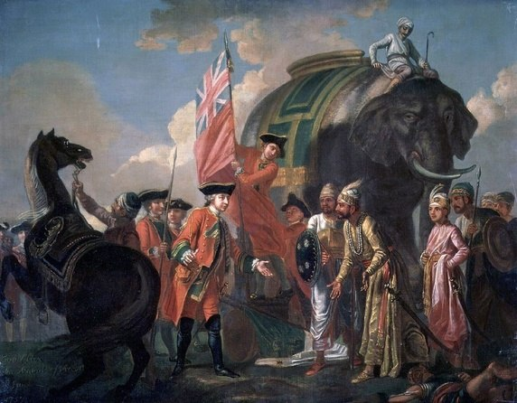  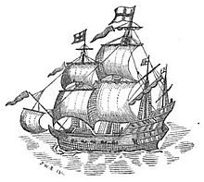 | 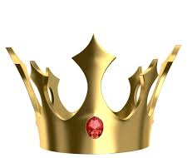  India: The Jewel in the Crown | 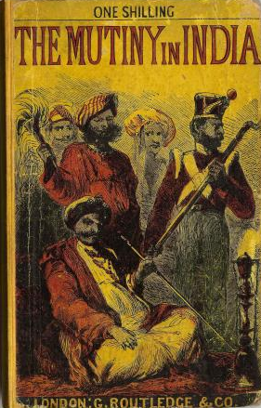  1857

Visual Summary British Imperialism in India

Directions: Carefully examine each of the pictures/cartoon. Each of the images conveys a part of the history of British imperialism in India. Cut each picture out and arrange them so that they tell the story. Glue the picture in place. Write a 1-2 sentence explanation below each picture that explains the picture (what does it represent?) and the reason it belongs in the order in which you placed it.

