The Human Ear – A Homework Assignment
Directions: Use the list below, your textbook, and the internet to correctly label each part of the ear. Then, record the missing definitions for each part.
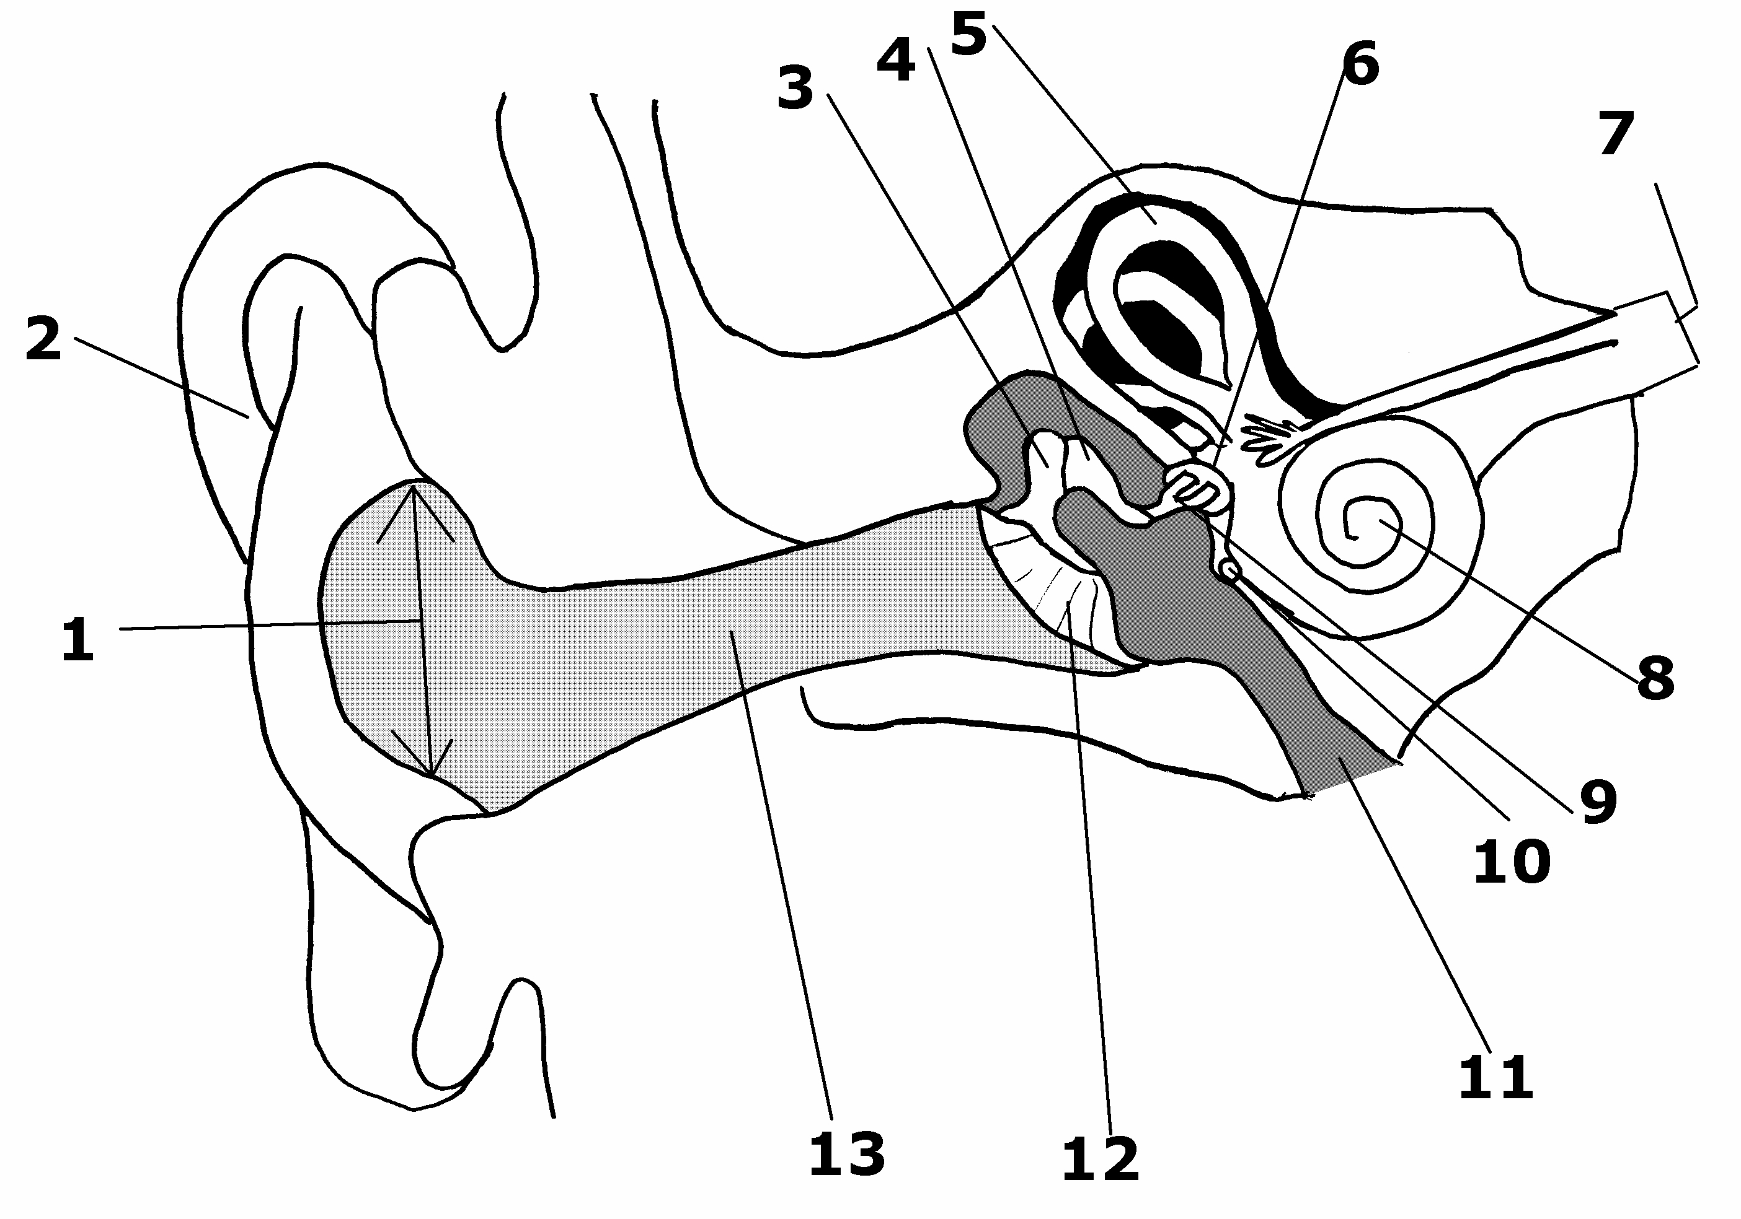

Ear Part | Definition
Tympanic membrane/ear drum

Pinna

Oval window

Ossicles (malleus – hammer, incus – anvil, stapes – stirrup) *Label all 3 on diagram !
Auditory canal

Cochlea

Auditory nerve

Semicircular canals

Round window | Small opening in the middle ear leading to the cochlea
Eustachian tube | Tube that connects the middle ear to the nasopharnyx

