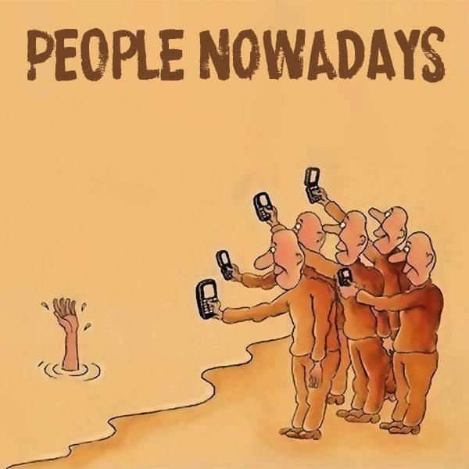
Applying the Bystander Effect

Part I: Read about the experiment/study -

Latané and Darley (1968)

- 72 university students (59 female and 13 male)
- They were asked to discuss kinds of personal problems new college students could have in an urban area.
- Each participant would be talking to other participants of a varying number in a discussion group but each of the participants has separate rooms (for anonymity). This conversation will take place over microphones and speakers.
- Each participant will be given two minutes to speak during their turn. All the microphones of other participants will be turned off. The subject is unaware that all the voices that he will hear are all pre-recorded voices. The number of voices that the subject will be 'talking to' depends on the treatment condition that he is in. There are five treatment conditions. First is a one-on-one conversation and the last is a group of six participants (1 subject and 5 pre-recorded voices).
- One of the pre-recorded voices is that of an epileptic student who is having seizures. During the first turn, a voice will confess to the group that he is prone to seizures and it could be life-threatening. During his second turn, the seizure will start.
- The real subject can only hear the event and he cannot see the actual participant who is having the seizure.
- The actual response that the experimenters will be measuring during this event is the time it will take for the subject to stand up, leave the room, look for the experimenters and ask for help (DV)

Results –
- Only 31% of the participants sought help
- Most important finding came from the one-on-one conversation, 85% of the subjects actually asked for help. This means that if the subjects think that they are the only one who knows about the incident, there is a higher probability that they will ask for help! THUS, THE GREATER NUMBER OF PEOPLE PRESENT DURING AN EMERGENCY – THE LESS LIKELY PEOPLE ARE TO HELP

Part II: Read the following list of factors developed by social psychologists to describe factors that influence when bystanders help and when they do not.

Factors that influence when bystanders will NOT HELP:
- They think they will be regarded foolishly by others
- They perceive that others are not helping for a good reason (this is called pluralistic ignorance –we assume that other people know something that we do not)
- They believe others will help instead of themselves (this is called diffusion of responsibility – the more bystanders present the less individually responsible they will feel)
- They are unfamiliar with their environment
- They perceive that recognition of the event by even a small action might require greater action on their part
Factors that influence when bystanders will HELP:
- They notice the situation - if people are in a hurry or inattentive, they may fail to realize there is a problem.
- The situation is unambiguous – they have to understand that it is an emergency.
- They believe no one else is available to help
- They are in an environment with which they are familiar
- They believe their actions will not put them in any danger

Part III: Applying What You Learned
Read the story below and answer the questions that follow.

Lenny Skutnik

On January 13, 1982, an airline bound for Tampa left National Airport in Washington D.C. A few minutes after takeoff, the plane hit a truck and six cars on a bridge over the Potomac River and then crashed into the ice-covered river. Emergency squads immediately started rescue operations and pulled five people from the icy water. Lenny Skutnik was standing on the riverbank. He took off his boots and his coat and dove into the river. He dragged two passengers from the thirty degree water.

- Using the factors suggested on the previous page, state 3 specific reasons why he helped:

- According to the factors on the previous page, are there reasons why he should NOT have helped? If so, list them.

- Stan is walking down a busy street on a snowy day. A homeless woman, crouched by the side of a building, is shivering.
- Does Stan help or not?

- Why or why not (use the factors)?

- What circumstances might change Stan’s behavior?

- Gary is visiting a college he hopes to attend. As he is walking across the campus, he sees a man lying on a walkway. Other students are just passing by the man.
- Does Gary help or not?

- Why or why not (use the factors)?

- What circumstances might change Gary’s behavior?

- Stacy is driving to a friend’s house late at night on an unfamiliar road. She sees a horrible car accident and several people standing nearby.
- Does Stacy help or not?

- Why or why not (use the factors)?

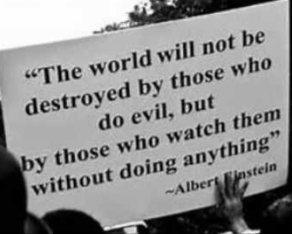
- What circumstances might change Stacy’s behavior?

