A History of the Treatment of
Individuals with Mental Disorders

The history of psychiatric hospitals was once tied tightly to that of all American hospitals. Those who supported the creation of the first early-eighteenth-century public and private hospitals recognized that one important mission would be the care and treatment of those with severe symptoms of mental illnesses. Like most physically sick men and women, such individuals remained with their families and received treatment in their homes. Their communities showed significant tolerance for what they saw as strange thoughts and behaviors. But some such individuals seemed too violent or disruptive to remain at home or in their communities. In East Coast cities, both public almshouses and private hospitals set aside separate wards for the mentally ill. Private hospitals, in fact, depended on the money paid by wealthier families to care for their mentally ill husbands, wives, sons, and daughters to support their main charitable mission of caring for the physically sick poor.
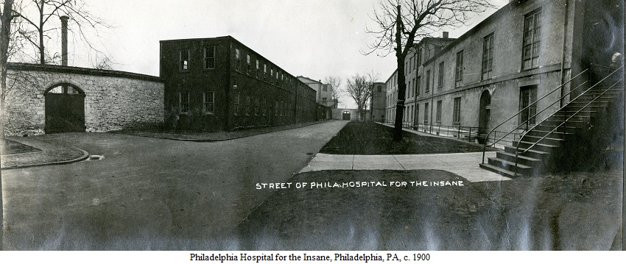

But the opening decades of the nineteenth-century brought to the United States new European ideas about the care and treatment of the mentally ill. These ideas, soon to be called “moral treatment,” promised a cure for mental illnesses to those who sought treatment in a very new kind of institution—an “asylum.” The moral treatment of the insane was built on the assumption that those suffering from mental illness could find their way to recovery and an eventual cure if treated kindly and in ways that appealed to the parts of their minds that remained rational. It repudiated the use of harsh restraints and long periods of isolation that had been used to manage the most destructive behaviors of mentally ill individuals. It depended instead on specially constructed hospitals that provided quiet, secluded, and peaceful country settings; opportunities for meaningful work and recreation; a system of privileges and rewards for rational behaviors; and gentler kinds of restraints used for shorter periods.

With both the ideas and the structures established, reformers throughout the United States urged that the treatment available to those who could afford private care now be provided to poorer insane men and women. Dorothea Dix, a New England school teacher, became the most prominent voice and the most visible presence in this campaign. Dix travelled throughout the country in the 1850s and 1860s testifying in state after state about the plight of their mentally ill citizens and the cures that a newly created state asylum, built along the Kirkbride plan and practicing moral treatment, promised. By the 1870s virtually all states had one or more such asylums funded by state tax dollars.
Kirkbride plan = Insane asylums would be massive, carefully structured buildings in secluded areas. Built on expansive grounds. Patients would have fresh air and a calm healthy environment. Seemed almost palace like from the outside.

Linear plan -a central administration building flanked by two wings comprised of tiered wards. This "linear plan" facilitated a hierarchical segregation of residents according to sex and symptoms of illness. Male patients were housed in one wing, female patients in the other. Each wing was sub-divided by ward with the more "excited" patients placed on the lower floors, farthest from the central administrative structure, and the better-behaved, more rational patients situated in the upper floors and closer to the administrative center.

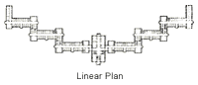

Timeline:

1773: The first hospital for the mentally ill in the US opened in Williamsburg, Virginia.

1840: There were only eight “asylums for the insane” in the United States. Dorothea Dix
crusaded for the establishment or enlargement of 32 mental hospitals, and transfer of those with
mental illness from almshouses and jails. First attempt to measure the extent of mental illness
and mental retardation in the United States occurred with the U.S. Census of 1840, which
included the category “insane and idiotic.”

It was common for homeless people, tramps and hobos to become ‘patients’ of the asylums seasonally for shelter and food, and then "elope," or slip away when the good weather returned. Families would often submit their elderly relatives to asylums because they lacked the resources or time to deal with them appropriately. The problem with overcrowding developed because the institutions had no established criteria for accepting or rejecting patients into their care. Rapid growth in populations caused patient care to suffer. In the Athens Asylum the patient population jumped from 200 to nearly 1800, with an insignificant alteration in staffing. The community found that these institutions were an easy means to remove unwanted people from society. There was no effort to provide any other programs or support, because the state was paying for the asylum.

The severe overcrowding led to a sharp decline in patient care and once again, the revival of old procedures and medical treatments. Restraints returned. Instead of sleeping in single rooms as the Kirkbride Plan had designed, patients were sleeping in wooden cribs stacked three patients high. Ice water baths were once again used, along with shock machines and electro- convulsive therapy. And in the early 1930s the notorious lobotomy was introduced into American medical culture.
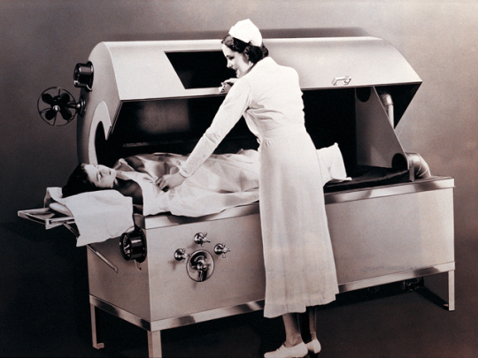

Restraints that were eventually outlawed
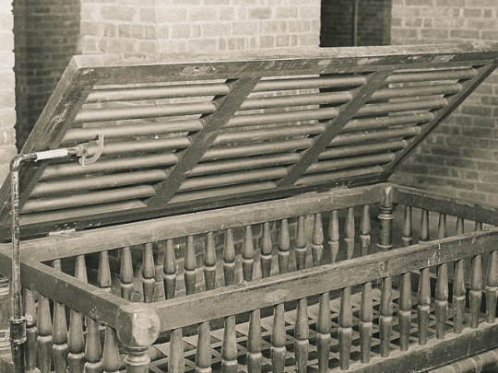

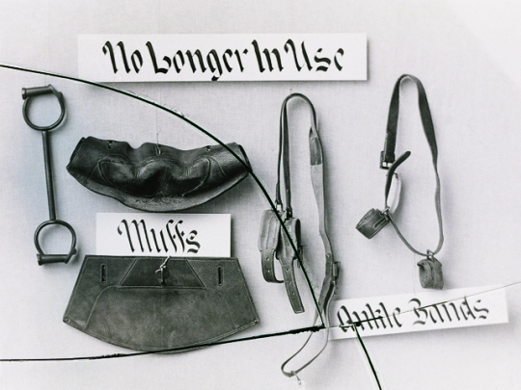

Fever therapy to treat psychosis
The Crib

Shortly after the asylum population explosion in the mid 1900s, when mental health treatment was arguably at its worst, an apparent salvation emerged. Psychotropic medication was pioneered. In 1954 the medical community introduced an anti-psychotic drug called Thorazine for the treatment of the mentally ill. In rapid succession, other psychotropic medications became available, making it possible to cut substantially the length of time patients stayed in mental institutions. This breakthrough led to a significant decline in asylum populations, and the gradual discontinuation of less humane treatments and procedures.

Reflecting the changes in the treatment of the mentally ill brought about by drug therapy, and state and federal public policies in the 1960s’ state institutions changed their procedures resembling the previous moral management revolution. There was an emphasis on protecting the human rights of the mental patients that had historically been overlooked.

Simultaneous with the breakthrough in medical treatment, the community mental health movement became a centerpiece of President John F. Kennedy’s congressional program. There were concurrent shifts in insurance coverage for the mentally ill provided by the Comprehensive Mental Health bill in 1964, and the Medicare and Medicaid Acts in 1966. All of these national movements led to a reduction of the use of existing mental health hospitals and an explosive growth in private hospitals, general hospitals with psychiatric wings, and community mental health centers.

In SUMMARY:
Deinstitutionalization began in 1955 with the widespread introduction of chlorpromazine, commonly known as Thorazine, the first effective antipsychotic medication. In addition, the desire to treat individuals with psychological illness within their own community played an important role in the movement to deinstitutionalize. Deinstitutionalization has two parts: the moving of the severely mentally ill out of the state institutions, and the closing of part or all of those institutions. The former affects people who are already mentally ill. The latter affects those who become ill after the policy has gone into effect and for the indefinite future because hospital beds have been permanently eliminated.
The magnitude of deinstitutionalization of the severely mentally ill qualifies it as one of the largest social experiments in American history. In 1955, there were 558,239 severely mentally ill patients in the nation's public psychiatric hospitals. In 1994, this number had been reduced by 486,620 patients.
Thus deinstitutionalization has helped create the mental illness crisis by discharging people from public psychiatric hospitals without ensuring that they received the medication and rehabilitation services necessary for them to live successfully in the community. Deinstitutionalization further exacerbated the situation because, once the public psychiatric beds had been closed, they were not available for people who later became mentally ill, and this situation continues up to the present. Consequently, approximately 2.2 million severely mentally ill people do not receive any psychiatric treatment.
Deinstitutionalization was based on the principle that severe mental illness should be treated in the least restrictive setting. This is a laudable goal and for many, perhaps for the majority of those who are deinstitutionalized, it has been at least partially realized.
For a substantial minority, however, deinstitutionalization has been a psychiatric Titanic. Their lives are virtually devoid of "dignity" or "integrity of body, mind, and spirit." "Self-determination" often means merely that the person has a choice of soup kitchens. The "least restrictive setting" frequently turns out to be a cardboard box, a jail cell, or a terror-filled existence plagued by both real and imaginary enemies.

