Chapter 11: Social Psychology
Conformity and Obedience to Authority

Let’s PRIME your brain for yer learnin!

TERM: DEFINITION: EXAMPLE:
social role | A socially defined pattern of behavior that is expected of a person in a given setting
script | A cluster of knowledge about the sequence of events and actions expected to occur in a particular setting
social norms | A group’s expectations regarding what is appropriate and acceptable for its members’ attitudes and behaviors

Notes – Conformity and Obedience

What is Social Psychology?

The Power of the Situation – Are We All Capable of Monstrous Acts???
- According to former APA president _____________________ (and other social psychologists) the answer is ____________!

- Just the right dose of certain social situations can transform ordinarily good people into evil-doers. He refers to it as the ____________________.

Terms:

- Conformity –

  - Normative influence – changing one’s behavior to fit in with the group.

Example(s)

  - Informational influence – when a person changes their behavior because they lack knowledge, so they look to the group for answers (they desire to be correct in their actions)

Example(s)

- Compliance - Similar to conformity. It is the act of _______________________________________ to someone else’s ________________. Usually it is used to accomplish a specific task. The person asking for the compliance is not asking for a change in beliefs or that you agree with what they are asking.
Example(s)

- Obedience - The act of following a __________________________from an authority figure. (Following orders without question)
Example(s)

Experiment #1 – The Asch Experiment - ____________________________

Hypothesis:

IV:

DV:

7 Factors that INCREASE Conformity:
- Subject feels _____________________
- The group has at least _______ people.
- The group is ___________________________.
- Subject admires the group.
- Subject has made no prior commitment to any response
- Others ________________ the subject’s behavior.
- The culture encourages respect for social standards.
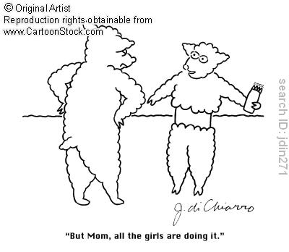

Conclusion/Asch Effect -

Experiment #2 – The Milgram Experiment - ______________________________

Hypothesis:

IV:

DV:

The Shocking Results!!!
Factors that INCREASED obedience -

- ___________________________________________________________

- ___________________________________________________________

- ___________________________________________________________
- ___________________________________________________________

Factors that did NOT increase obedience –

- ___________________________________________________________

- ___________________________________________________________

- ___________________________________________________________

- ___________________________________________________________

Ethical Concerns of Conducting the Milgram Experiment

- Potential _________________________ harm – participants were exposed to an extremely stressful situation.

- Many participants were visibly _________________.

- Deception - ____________________________________________

________________________________________________________

No pun intended…well maybe

