Chapters 2 & 3 Assignment Calendar 2016
Biological Bases of Behavior & Sensation and Perception
Class Date | In-Class Content | Homework Assignment  (DUE next class)
- Tuesday, Sept. 27th  - Wednesday, Sept. 28th | 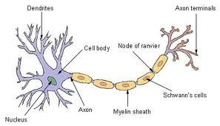  Neurons  Go over Test  Examine FRQ  Give out Brain Mnemonic Assignment | Chapter 2 Read pp. 64-73 and take reading notes:  - Nervous System  - Endocrine System
- Thursday, Sept. 29st  - Friday, Sept. 30th | Neurons/neurotransmitters  Nervous System  Endocrine System | - Finish Up Web-quest
- Monday, October 3rd  B - Tuesday, October 4th | Brain Mnemonic Assignment –Research and planning/preparation  Deepest Cut article and questions | Chapter 2 Read pp. 85-94 and take notes  - Hemispheric Specialization, Split Brain Research  Finish Brain Mnemonic Assignment; have completed and ready for your assigned day to present to the class!  Study for Quiz on Neurons next class
- Wednesday, Oct. 5th  - Thursday, Oct. 6th | Neurons Quiz  Brain Mnemonic Presentations Day 1  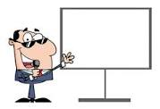 | Study for 1st Worst Quiz Ever on the Brain  Reading Notes from Ch. 8 pp. 312-314  - Chromosomes, Genes, DNA  (take good notes – I won’t be addressing this in class)
- Friday, Oct.. 7th  - Monday, Oct. 10th | Brain Mnemonic Presentations Day 2  Study/Prepare for 2ND WORST QUIZ EVER… | Study for 2nd Worst Quiz Ever
- Monday, Oct. 3rd  - Tuesday, Oct. 4th | The 2nd Worst Quiz EVER!  Brain Scans/Images  Begin Brain/Nervous System/Endocrine System Application Video Analysis | Make sure ALL Reading Notes are complete.  Review Class notes for Chapter 2
- Wednesday, Oct. 5th  - Thursday, Oct. 6th – | Finish Brain and Nervous System Application Video Analysis  Chapter 2 Study Guide Given | Use study guide to continue preparing for test.
- Friday, Oct. 7th  - Monday, Oct. 10th | Wernicke and Broca’s Area  Hemispheric Specialization  Video: The Human Body – Pushing the Limits (Brain Power) | LAST chance to study before test!!!!!
- Tuesday, Oct. 11th  *Wednesday, Oct. 12^{h} – No School (Yom Kippur)  - Thursday, Oct. 13th | Chapter 2 Test  - 50 Multiple Choice  and 1 FRQ | Ch. 3 Read pp. 98-103 and take reading notes:  - Sensation vs. perception and  Sensory thresholds
- Friday, Oct. 14th  - Monday, Oct. 17th | Sensation vs. Perception  Transduction  Thresholds  Sensory adaptation | Read pp. 104-111 and take reading notes:  - Vision  - Complete diagram of the EYE (label, color, and define)
- Tuesday, Oct. 18th  - Wednesday, Oct. 19th  *Thursday, Oct. 20th – No school for students (Parent-Teacher Conferences)  *Friday, Oct. 21st (No school for students – PD for teachers) | Weber and Fechner’s laws  (Somatosensory cortex and perception)  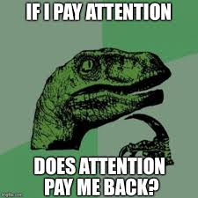  Signal Detection Theory | Read pp. 112-116 and take reading notes  • Audition, Olfaction, Gustation, and Pain  - Complete EAR diagram (label, color, and define)
Important Information for 1st MP

- There will only be 2 chapter tests this marking period (Ch. 1 and Ch. 2)
- You may redo any 4 class work assignments or assessments
- You have 10 school days from the day the assignment is returned to you to complete the redo (you must see me during lunch or after school to schedule)
- IF you choose to complete Test Corrections on a chapter test, that takes the place of a redo (you will get 1/3 of a point for each correct answer)
- You will only have the choice of one test correction per marking period.

- The quarterly assessment is 10% of the grade for the marking period

