You should be able to identify who these people are – what are they known for in Psychology!
Key People
Maslow Rotter Selye
McClelland Lewin Ekman
Dweck Lorenz

You should be able to define/explain/and provide an example (when appropriate) for the following terms. In addition, please remember this list should be used in combination with your textbook.
Key terms/concepts

- Instinct (fixed- action pattern)/Instinct theory
- Imprinting
- Incentive theory
- Drive-reduction theory
- Homeostasis
- Arousal theory
- Humanistic theory and Hierarchy of needs
- Peak experiences
- Evolutionary theory
- Theory X/Theory Y
- Overjustification
- Learned helplessness
- Locus of control
- Intrinsic motivation
- Extrinsic motivation
- Self efficacy
- Achievement motivation ( David McClelland - TAT)
- Set point (hunger motivation/weight)
- Anorexia nervosa, bulimia nervosa, and binge-eating disorder
- Lesions to the Ventromedial hypothalamus or the lateral hypothalamus
- Motives in conflict
- Cross-cultural perspective on motivation: Individualism v. Collectivism
- Universal facial expressions (Paul Ekman)
- Display rules
- Microexpressions
- Lateralization of emotion (positive emotions are controlled by the left hemisphere of brain and negative are controlled by the right)
- Schachter-Singer Two-factor theory
- James-Lange Theory
- Facial feedback hypothesis
- Cannon-Bard Theory
- Opponent-Process Theory
- Cognitive appraisal Theory
- Types A/B/C personality
- Hardy personality type (hardiness)
- General Adaptation Syndrome (GAS)
- Stages of stress (alarm, resistance, exhaustion)
- Phases of sexual response (sexual motivation)
- Master’s and Johnson and the Kinsey studies
- Yerkes-Dodson law/inverted U diagram
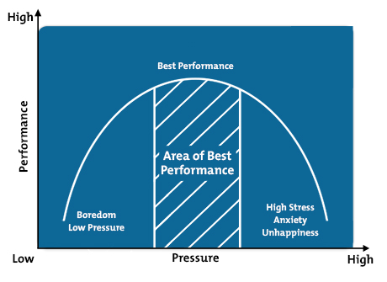

This means I can still test terms that were in your book, but not on this list

